

**Assignment**

1. **What is software? What is software engineering?**

* Software is considered to be collection of executable programming code, associated libraries and documentations. Software, when made for a specific requirement is called software product. Engineering on the other hand, is all about Developing Products, using well-defined, Scientific principles and methods.

1. **Explain types of software.**

* **System Software :** 
  + - This type of software includes operating systems, device drivers, utilities, and other programs that enable the basic functions of computer hardware and provide a platform for running application software. Examples include Microsoft Windows, macOS, Linux, and device drivers for printers and graphics cards.
* **Application Software**
  + - * Application software is designed to perform specific tasks or solve particular problems for users. It includes a wide range of programs such as word processors, spreadsheets, web browsers, email clients, media players, graphic design tools, and games.

1. **What is SDLC? Explain each phase of SDLC.**

* SDLC stands for Software Development Life Cycle. It is a structured process used by software development teams to design, develop, test, and deploy software applications. SDLC consists of several phases, each with its own set of activities, deliverables, and goals. Here are the phases of the SDLC:

1. **Requirement Gathering and Analysis :**

* In This Phase, the development team gathers and analyses requirements from stakeholders, end-users, and other sources.
* The goal is to understand the needs and expectations for the software application.
* Activities include conducting interviews, holding workshops, and creating documentation like user stories, use cases, and requirements specifications.

1. **Design:**

* During the design phase, the development team translates the requirements gathered in the previous phase into a detailed design plan for the software.
* This includes designing the system architecture, database structure, user interface, and other components.
* The output of this phase includes architecture diagrams, data models, interface prototypes, and design documents.

1. **Implementation (Coding):**

* In this phase, the actual coding or programming of the software application takes place.
* Developers write code according to the design specifications and coding standards.
* Continuous collaboration and communication among team members are crucial during this phase to ensure that the software is developed according to requirements and design.

1. **Testing:**

* The testing phase involves verifying and validating the functionality, performance, and quality of the software.
* Different types of testing such as unit testing, integration testing, system testing and acceptance testing are conducted to identify defects and ensure that the software meets its requirements.
* Test cases and test plans are developed based on the requirements and design specifications.
* Defects and issues discovered during testing are reported, tracked, and addressed by the development team.

1. **Deployment:**

* Once the software has been developed and tested successfully, it is prepared for deployment to the production environment.
* This involves packaging the software ,creating installation scripts, and documenting deployment procedures.
* Deployment may also include data migration, user training, and coordination with IT operations teams.
* The software is rolled out to end-users or customers, and its performance and stability are monitored during the initial deployment phase.

‘

1. **Maintenance:**

* The maintenance phase involves ongoing support, updates, and enhancements to the software after it has been deployed.
* This includes fixing bugs, addressing user feedback, adding new features, and adapting the software to changes in the environment or technology.
* Maintenance activities help ensure the long-term viability and usefulness.

1. **What is DFD? Create a DFD diagram on Flipkart.**

* DFD stands for Data Flow Diagram. It's a graphical representation of the flow of data within a system, illustrating how data moves from one process to another, how it's stored, and how it's used within the system.
* DFDs are commonly used in system analysis and design to model the flow of data in information systems, helping to understand system requirements, identify potential bottlenecks, and clarify system functionalities. They are also helpful in documenting and communicating the structure of a system to stakeholders.
* **DFD Diagram on Flipcart:**

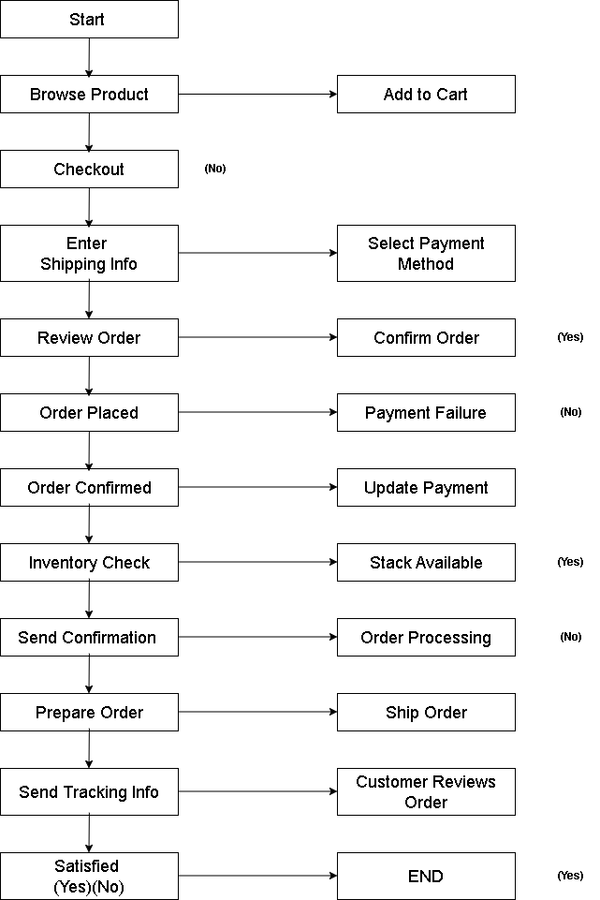

1. What is Flow chart? Create a flowchart to make addition of two numbers

* A flowchart is a type of diagram that represents a workflow or process. A flowchart can also be defined as a diagrammatic representation of an algorithm, a step-by-step approach to solving a task.

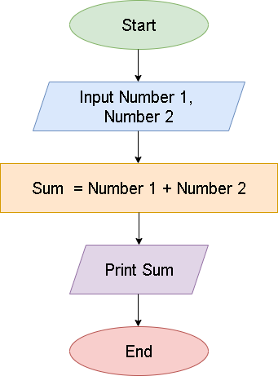

1. **What is Use case Diagram? Create a use-case on bill payment on paytm.**

* A Use Case Diagram is a type of Unified Modeling Language (UML) diagram that represents the interaction between actors (users or external systems) and a system under consideration to accomplish specific goals. It provides a high-level view of the system’s functionality by illustrating the various ways users can interact with it.

